Chapter 14, Problem 59.

Find the bandwidth and center frequency of the bandstop filter of Fig. 14.89.

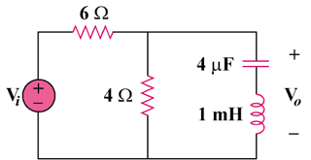

Figure 14.89
For Prob. 14.59.

